Student’s Name
Course Name
Professor’s Name
Date
Gun violence is a public health issue in the United States
Gun violence has been a problem for a very long time in the United States and is clearly getting out of hand. Many Americans lose their lives daily and other injured from gun violence. According to CDC, 85,000 people are injured and 38,000 others die from gun violence every year. Americans are 25 times more likely to be killed in a gun homicide than people in other high-income countries. Gun violence has many heath implications both to the victims and the government. For example, gun violence is the leading cause of premature deaths in the US. It has devasting effects on the health of individuals and increases the cost of healthcare to the government. It is for these reasons that gun violence should be seen as a public health issue. This paper will give reasons why gun violence should be considered a public health issue in the US and gives solutions/measures to curb gun violence in the US. The paper also compares civilian gun-ownership between USA and other countries using a chart.
Gun ownership in America vs. other countries
The high rate of gun violence in the US is attributed to the fact that many civilians own guns than other countries. It is estimated that over 90% of Americans own guns whereas only 7% of UK residents own guns. Furthermore, in the US, private sales between individuals are allowed whereas in the UK it is prohibited. Also, online purchasing of guns is allowed in the US while UK only permits face-to-face selling of guns. The UK is one of the countries that have strict gun legislation policies worldwide.
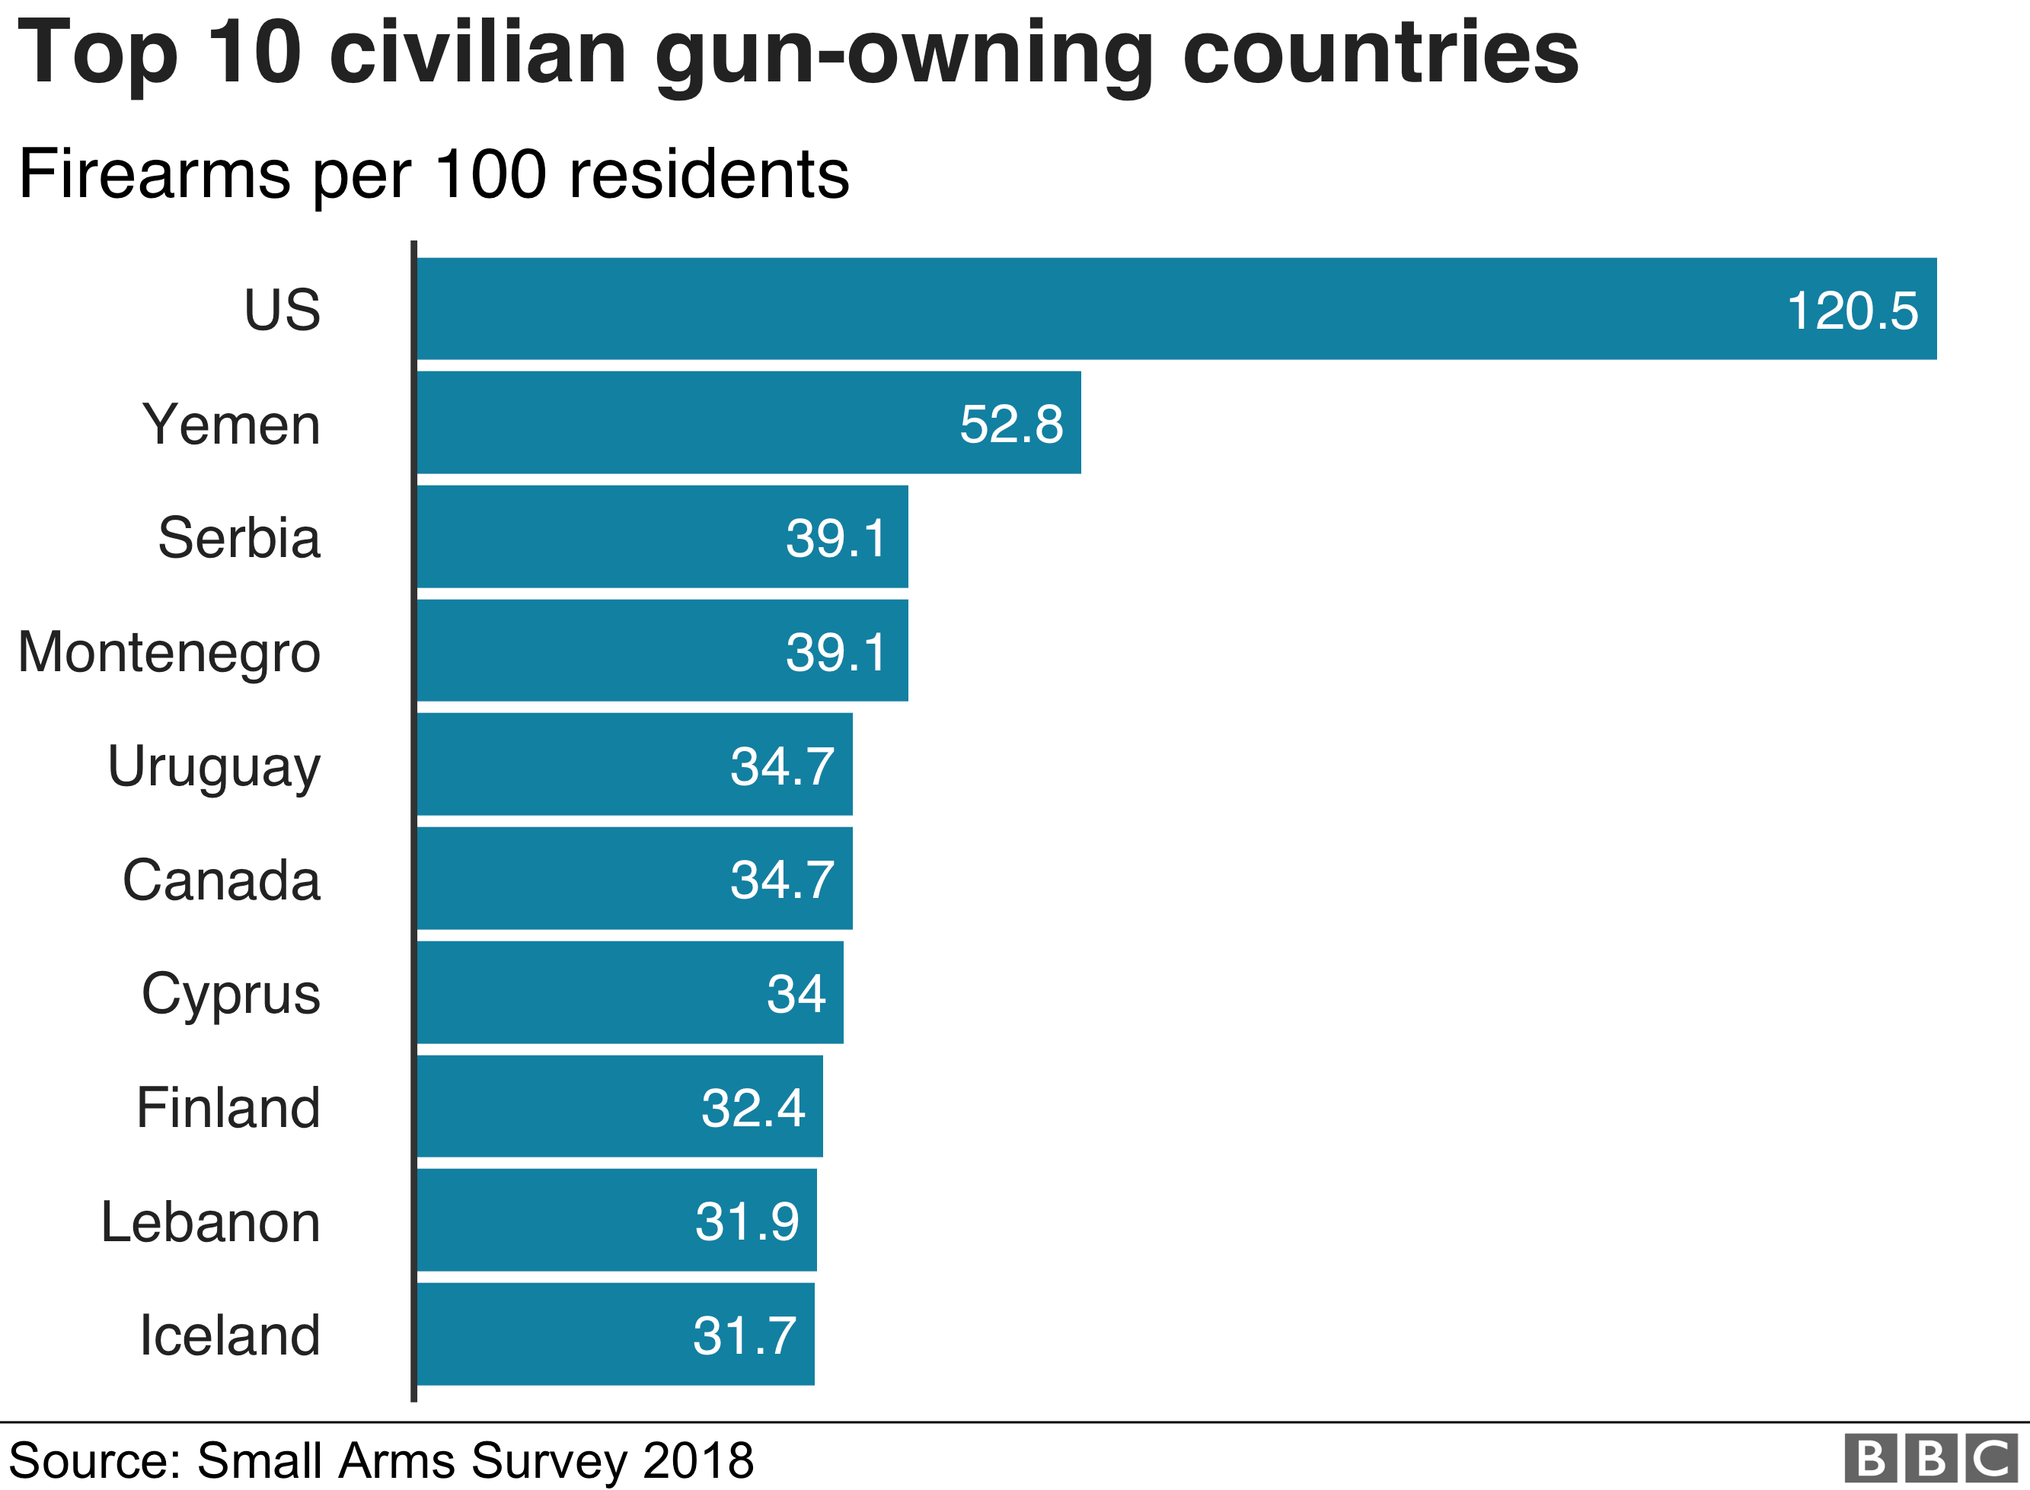
This chart shows that US is the world leading country in terms of civilian-gun ownership. The country has more guns than people! This explains why the country has the highest number of gun homicides than any other country in the world.
Why gun violence should be considered a public health issue
To begin with, when people die, their families are touched in some way. This could be a psychological or societal issue. When weapons are involved, this becomes even more of a concern because people become hyper-aware, which affects the entire nation. As a result of shootings and gun violence, there have been numerous recorded and unreported homicides and murders in the United States (Alcorn, 2017, 130). This is a subject that should affect every citizen in the United States. For example, homicide became frequent in the United States in the 19th century, and the rate has steadily increased since then. According to statistics the rate of homicide, for example, was at an all-time high in the early 1990s. For instance, out of the 15,498 murders registered in 2018, 5.0 persons per 100,000 were judged to have been victims of gun homicide (Follman et al., 18). It is estimated that 100 Americans die every from gun violence. Gun violence is the leading cause of premature death in America causing 85,000 injuries and 38,000 deaths every year. More people are killed by firearms more than traffic accidents in 2019 (CDC). For this reason, gun violence should not just be seen as a criminal justice issue, but a public health issue as well.
The other reason why gun violence should be considered a public health issue in the US is the psychological trauma and stress associated with gun violence. People who have experienced gun violence may experience depression, anxiety, stress, and post-traumatic stress disorders (PTSD) which are new health issues altogether. The effects are experienced not just by the victims but also the neighbors, witnesses and bystanders. Gun violence, has an impact on a person's mental, social, emotional, physical, and mental health. When gun violence victims recuperate and reintegrate into society, they are psychologically unprepared in terms of traumas that might lead to despair (Johnson & Allan, 48). Some various situations and events may cause the recovering person to commit suicide or go insane. Aside from mental health, a person's death has a social impact. For example, victims of gun violence will have a difficult time returning to normal following the catastrophe. They may wind up staying inside and committing further crimes, which continues the cycle of crime and violence (Wallace, 2). Gun violence has an economic impact because when parents and breadwinners are killed, children and beneficiaries are left to hustle and struggle for themselves, which leads to their engaging in gun crimes, which increases gun violence in the United States.
Additionally, gun violence makes people live in fear which affects their health. Living under threat affects the heath of individuals. The medical costs associated with gun violence is another concern. It is estimated that the cost of medical treatment for survivors of gun injuries surpasses $1 billion every year. This includes the cost of medical treatment and hospitalization. This is a lot of money that is lost in medical expenses associated with gun violence.
African Americans in the United States have been disproportionately affected. This is due to the existence of racism (Swanson, 6). For example, in the United States, African Americans make up the majority of those who are unjustifiably shot. People tend to connect black Americans with violence and crime, which is neither accurate nor correct. However, not just black people are vulnerable to gun violence. Still, all inhabitants of the United States are, since numerous white people have been reported to have died due to weapons being misfired or purposely fired.
According to the criminal justice system in the United States, African Americans have been found to be linked to homicidal cases, with the view that most African Americans have been faced with socioeconomic factors such as poverty, exposure to bad neighborhoods, poor access to public education, and poor access to early childhood education (Wright, 20). As a result, the black race in the United States is subjected to a high level of gun violence, including homicide, assault, and deadly police shootings. According to studies, 26 Black Americans are killed by guns every day on average, with another 104 suffering non-fatal injuries. Sixty-eight percent of homicide victims are African-Americans.
The government's act of legalizing gun ownership is the leading source of gun violence. This is due to the fact that some people have weapons and are free to use them whenever they want and for the wrong reasons of violence. In the United States, for example, approximately 47% of individuals have access to firearms (Cox, 219-220). As a result, there is a significant danger of gun violence since guns are left unattended and in the hands of criminals. Every year, roughly 39,000 people are killed by weapons. The child prevention act, the right to carry, and the stand your ground statute are among the laws that contribute the most to gun deaths. Restricting gun laws will significantly reduce the number of occurrences of gun violence and fatalities. A citizen of the United States has the right to keep and bear arms, according to the second amendment. Some citizens, such as criminals, have taken advantage of the second amendment by obtaining weapons and using them for violence.
When a person has access to firearms, they are more likely to commit suicide, engage in armed robbery and assault, domestic violence in the house, intentional homicide, accidental firearm deaths, and police brutality. All of these crimes are likely to occur, and they harm everyone, according to data. They are also the leading cause of gun deaths in the United States. This is also why the rate of gun deaths in the United States is rising faster than other causes of death, such as car accidents and fires.
According to studies, the year 2020 was the bloodiest in terms of gun violence (Sutherland et al., 225-226). This is because gunshots have been reported in places including restaurants, grocery stores, celebration grounds, hospitals, and cemeteries, as well as many other gatherings across the United States. This year, 2021, has seen a surge in gun violence occurrences, with 120 people becoming victims in only one weekend, with most of these incidents occurring in Chicago and Savanna. This demonstrates that having guns in the hands of random persons indicates that more significant killing will occur.
Various measures can be taken to curb gun violence in the United Sates. For example, as part of the legalization of gun ownership under the second amendment's gun policy, the government must revise and restate the legislation so that people and criminals do not take advantage of the policy (Cox, 219-220). When we see racism in action, associating it with police brutality and unjustifiable executions, the law enforcement officers must step up and do what they are supposed to do.
Secondly, smart technology should be used in all guns. This technology ensures that only the licensed person can use the gun. It uses fingerprint that ensures the gun cannot be unlocked by another person. This technology can be used to avoid mass shootings. This will help those who get access to other individuals’ guns and use them to commit a crime and commit suicide. It will also help identify individuals' rightful owners of the weapon in case of the crime committed. It is similar to the law that was done in New Jersey where the manufactures were required to make only personalized guns.
Another way to reduce gun problem is by ending the immunity for the guns’ manufacturers. The federal laws offered the industries used to protect and shield the firearms and sales manufacturers from the victims' civil claims. If the law is enacted, the manufacturers will make the companies make firearms safe for use and protect the guns' misuse.
Raising the age for the ownership of guns is another measure that can help reduce the problem of gun violence. The federal government should raise the legal age of gun ownership from 18 to 21 as well as banning sale of semi-automatic weapons. Proper licensing of guns would also be a helpful measure. Before licensure, gun owners should have modest training programs according to the rules set in firearms regulations.
In conclusion, all of the repercussions of gun violence have been demonstrated to have a significant influence on public health. Gun violence should be regarded a public health issue because it is the leading cause of premature death in America, leads to high cost of medication (over $1 billion every year) and makes people live in fear. Additionally, gun violence causes psychological trauma, stress, anxiety and depression to the victims and survivors of gun injuries. These effects warrant gun violence to be considered a public health issue, not just a criminal justice issue. Gun violence has societal, economic, and physical consequences that have an impact on the lives of every individual in the United States in some way. For this reason, various measures and policies should be implemented to reduce and curb the number of deaths and injuries associated with gun violence. Some of the measures include legislation, technology and raising the legal age of gun ownership.

Works Cited
Alcorn, Ted. "Trends in research publications about gun violence in the United States, 1960 to 2014." JAMA internal medicine 177.1 (2017): 124-126.
Cox, Karen S. "A public health crisis: Recommendations to reduce gun violence in America." Nursing outlook 66.3 (2018): 219-220.
Follman, Mark, et al. "The true cost of gun violence in America." (2018).
Johnson, Dré, and Allan E. Barsky. "Preventing gun violence in schools: Roles and perspectives of social workers." School social work journal 44.2 (2020): 26-48.
Sutherland, Mason, Mark McKenney, and Adel Elkbuli. "Gun violence during COVID-19 pandemic: paradoxical trends in New York City, Chicago, Los Angeles and Baltimore." The American journal of emergency medicine 39 (2021): 225-226.
Swanson, Jeffrey W. "The color of risk protection orders: gun violence, gun laws, and racial justice." Injury Epidemiology 7.1 (2020): 1-6.
Wallace, Lacey N. "Gun violence: an introduction." (2020): 1-2.
Wright, James D., Peter H. Rossi, and Kathleen Daly. Under the gun: Weapons, crime, and violence in America. Routledge, 2017.

